EXPERIMENT NO. 26

Cloning an Existing GitHub Repository and Making Changes

Aim
To clone an existing GitHub repository to the local machine, modify one of its files, and save the changes using Git.

Software Requirements
- Windows 10/11 (or Linux/macOS)
- Git
- GitHub Account
- Visual Studio Code (or any code editor)
- Web Browser
- Internet Connection

Theory
Git allows users to copy (clone) a remote repository from GitHub to their local machine. After cloning, files in the repository can be viewed and modified locally. These changes can later be committed and pushed back to GitHub if required.

Procedure
Step 1: Choose a GitHub Repository
- Open GitHub.
- Select an existing public repository (your own or any sample repository).
- Copy the repository URL.
Example:
https://github.com/YourUsername/RepositoryName.git

Step 2: Clone the Repository
Open Git Bash or Terminal.
git clone https://github.com/YourUsername/RepositoryName.git

Step 3: Navigate to the Repository
cd RepositoryName

Step 4: Open the Project
Open the repository in Visual Studio Code.
code .

Step 5: Edit a File
- Open any file (for example, README.md).
- Make a small change such as: add a new line of text, correct a spelling mistake, or fix a typo.
- Save the file.
Example:
# Sample Project
This repository is used to practice Git cloning and file editing.
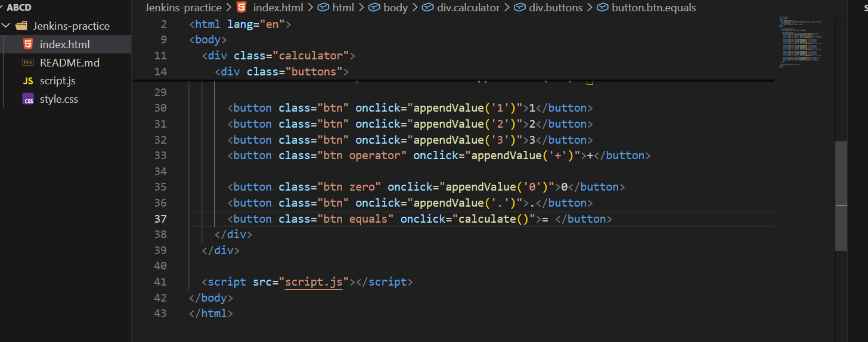
Step 6: Verify the Changes
Check the repository status.
git status

The modified file will be listed.

Screenshots
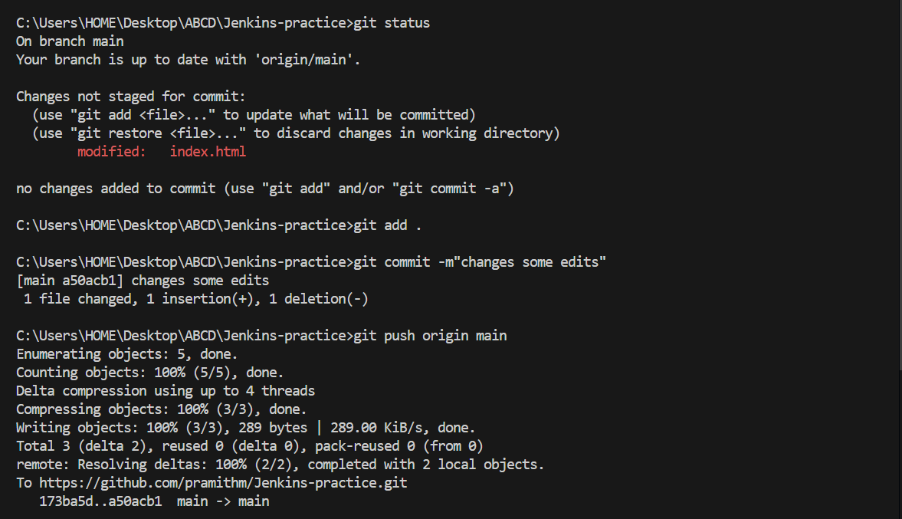

Observation
- The GitHub repository was cloned successfully.
- The project was opened on the local machine.
- A file was edited successfully.
- The changes were saved.
- Git detected the modified file.

Result
The existing GitHub repository was successfully cloned to the local machine. A file in the repository was modified, the changes were saved, and Git successfully detected the updated file.

